***Solution of Equations by Numerical Methods***

Introduction

In Mathematics there are many equations which the solutions of are harder or impossible to find by a normal algebraic method, and therefore these equations will have to be solved via numerical methods. To find these solutions we will be using three different methods, these methods are:

* Decimal search
* Fixed Point Iteration
* Newton-Raphson Method

After finding the solutions to my equations using the three methods I will be comparing all three to find out which method is the most efficient.

Decimal search

Decimal search is the process of looking at the values of f(x) around the point of intersection with the x-axis. By looking at these functions we will see a change in sign between two points, we know that the solution will be in between the two points when the change sign as one will be above the axis and the other below, this means that the point of intersection lies between those two points. I will be using this method on the equation and graph seen below:

.

Figure 1: , with 3 roots

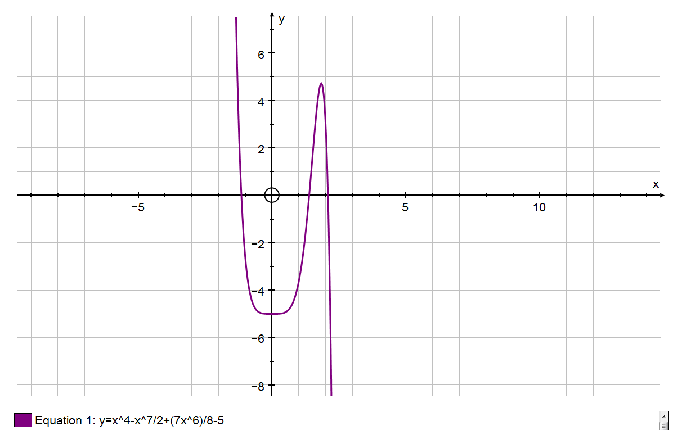

The roots of my equation lie in the intervals of [-2,-1], [1,2] and [2,3].

Figure 2: one of the 3 roots for the graph, this root is in the interval of [2,2.1]

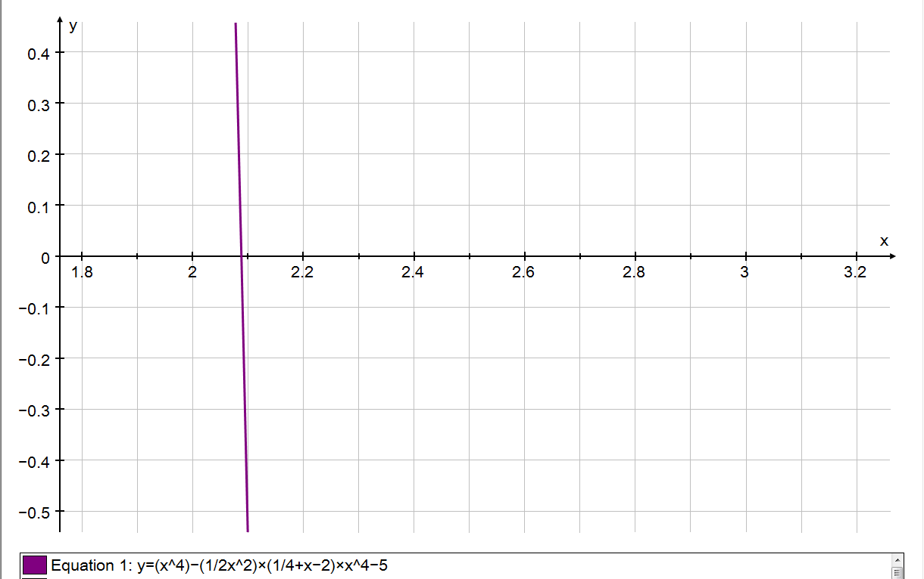

To solve the equation above we have to equate it to 0 and from there we will be able to find the roots of the equation.

We know that the equation f(x) = 0 has a solution in the interval [2, 3], using the table of values below we can see that there is a sign change between the x-values of 2 and 2.1 therefore we know that the root lies in the interval [2, 2.1]. This means that or .

x f(x)

2 3

2.1 -0.561

2.2 -7.085

2.3 -17.73

2.4 -33.93

2.5 -57.49

2.6 -90.59

2.7 -135.9

2.8 -196.5

2.9 -276.3

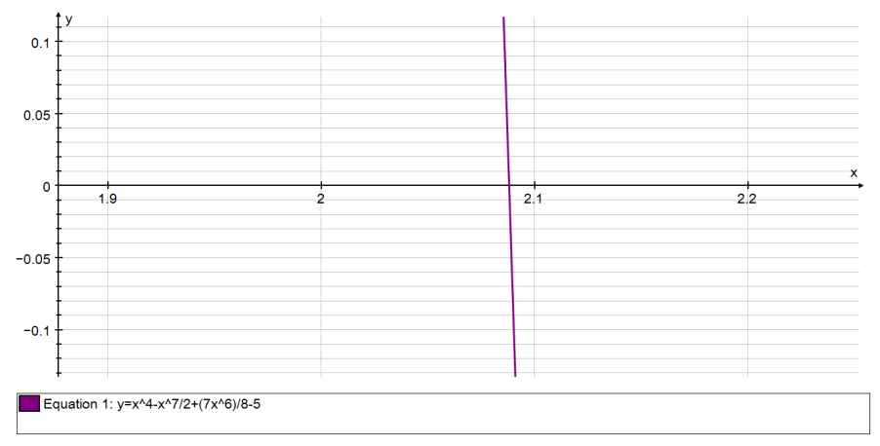From above we know that the equation f(x) = 0 has a solution in the interval [2, 2.1], using the table of values below we can see that there is a sign change between the x-values of 2.08 and 2.09 therefore we know that the root lies in the interval [2.08, 2.09]. This means that or .

x f(x)

2 3

2.01 2.75

2.02 2.478

2.03 2.185

2.04 1.868

2.05 1.528

2.06 1.163

2.07 0.7728

2.08 0.356

2.09 -0.08829

2.1 -0.561

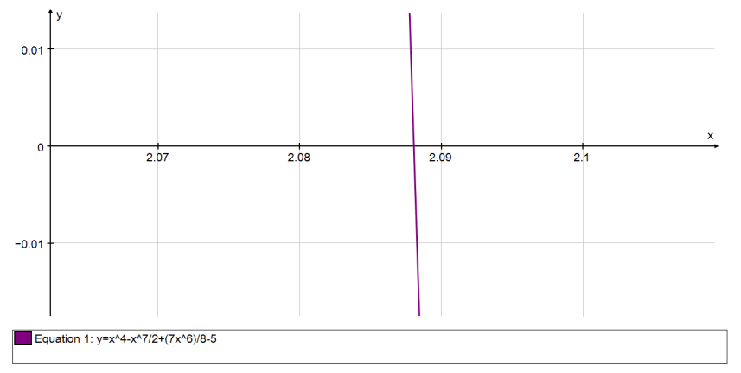From above we know that the equation f(x) = 0 has a solution in the interval [2.08, 2.09], using the table of values below we can see that there is a sign change between the x-values of 2.088 and 2.089 therefore we know that the root lies in the interval [2.088, 2.089]. This means that or .

x f(x)

2.08 0.356

2.081 0.3128

2.082 0.2693

2.083 0.2256

2.084 0.1816

2.085 0.1373

2.086 0.09277

2.087 0.04792

2.088 0.002801

2.089 -0.0426

2.09 -0.08829

From above we know that the equation f(x) = 0 has a solution in the interval [2.088, 2.089], using the table of values below we can see that there is a sign change between the x-values of 2.088 and 2.089 therefore we know that the root lies in the interval [2.088, 2.0881]. This means that or .

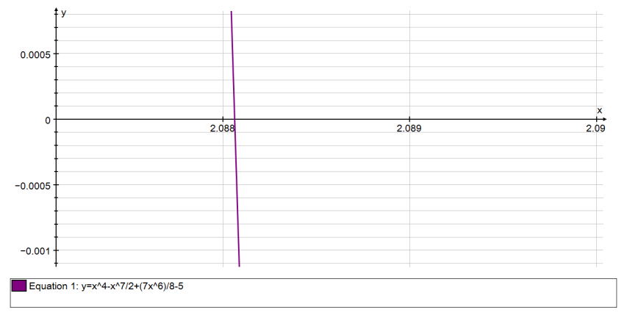

x f(x)

2.088 0.00280123067

2.0881 -0.00172658577

2.0882 -0.00625722496

2.0883 -0.0107906879

2.0884 -0.0153269755

2.0885 -0.0198660888

2.0886 -0.0244080289

2.0887 -0.0289527966

2.0888 -0.033500393

2.0889 -0.0380508191

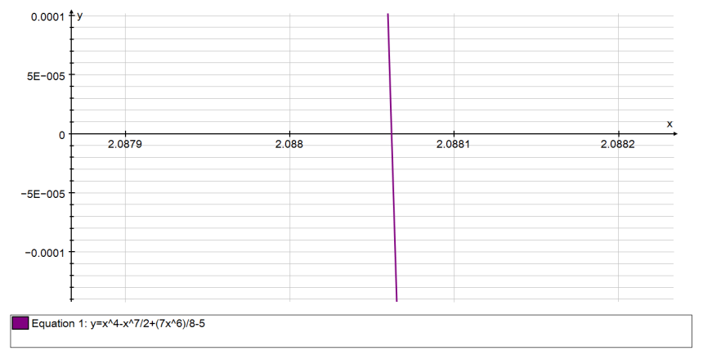From above we know that the equation f(x) = 0 has a solution in the interval [2.0880, 2.0881], using the table of values below we can see that there is a sign change between the x-values of 2.08806 and 2.08807 therefore we know that the root lies in the interval [2.08806, 2.08807]. This means that or .

x f(x)

2.088 0.00280123067

2.08801 0.00234857602

2.08802 0.00189589316

2.08803 0.00144318207

2.08804 0.00099044276

2.08805 0.00053767523

2.08806 8.48794784E-005

2.08807 -0.000367944497

2.08808 -0.000820796697

2.08809 -0.00127367712

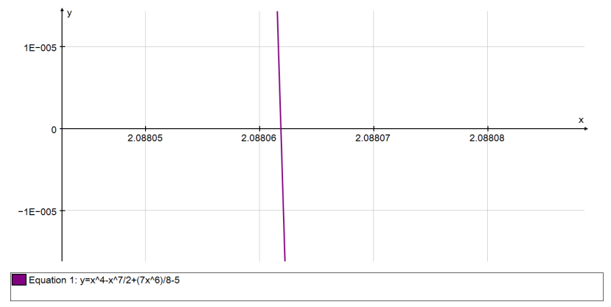From above we know that the equation f(x) = 0 has a solution in the interval [2.08806, 2.08807], using the table of values below we can see that there is a sign change between the x-values of 2.088061 and 2.088062 therefore we know that the root lies in the interval [2.088061, 2.088062]. This means that or .

x f(x)

2.08806 8.48794784E-005

2.088061 3.95983509E-005

2.088062 -5.68305878E-006

2.088063 -5.09647507E-005

2.088064 -9.62467249E-005

2.088065 -0.000141528981

2.088066 -0.00018681152

2.088067 -0.000232094341

2.088068 -0.000277377444

2.088069 -0.000322660829

From above we know that the equation f(x) = 0 has a solution in the interval [2.088061, 2.088062], using the table of values below we can see that there is a sign change in the interval the x-values of 2.0880618 and 2.0880619 therefore we know that the root lies in the interval [2.0880618, 2.0880619]. This means that or .

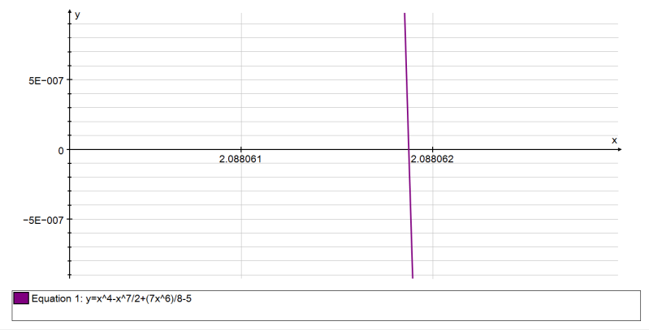x f(x)

2.088061 3.95983509E-005

2.0880611 3.50702227E-005

2.0880612 3.05420916E-005

2.0880613 2.60139577E-005

2.0880614 2.14858209E-005

2.0880615 1.69576814E-005

2.0880616 1.2429539E-005

2.0880617 7.90139382E-006

2.0880618 3.37324581E-006

2.0880619 -1.15490503E-006

2.088062 -5.6830587E-006

The final solution to my decimal search method is 9SF

Failing cases

In some cases finding the roots will not work, including when the graph touches the x-axis; when graph have repeated roots. Another case is for a reciprocal graph where the table of values will show a sign change at the asymptote when there is no root at that point; this is known as a false root. The third case is when the roots are situated close together and you can’t distinguish each individual one easily.

Close roots

Below in figures 3-4 you can see the graph:

This graph has 2 sets of roots which are situated close together with the intervals [0, 0.3], [-5.3, -5.4]. As you can see the pairs of roots are close together.

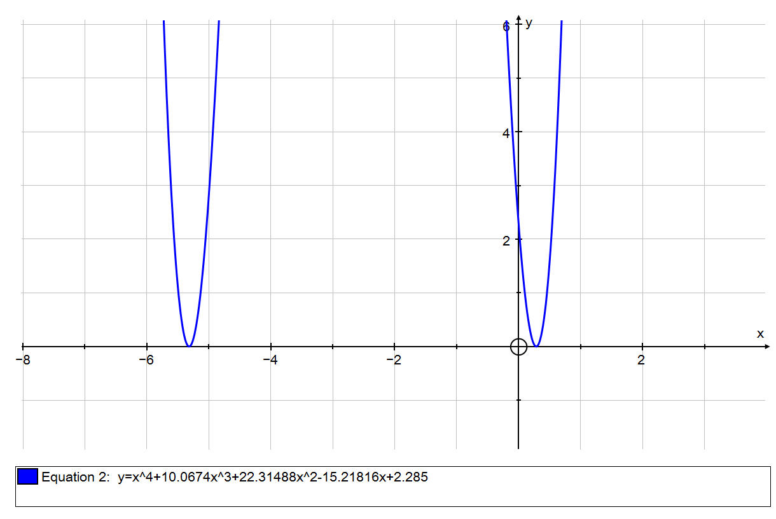

Figure 3: Failing case for when roots are close together,

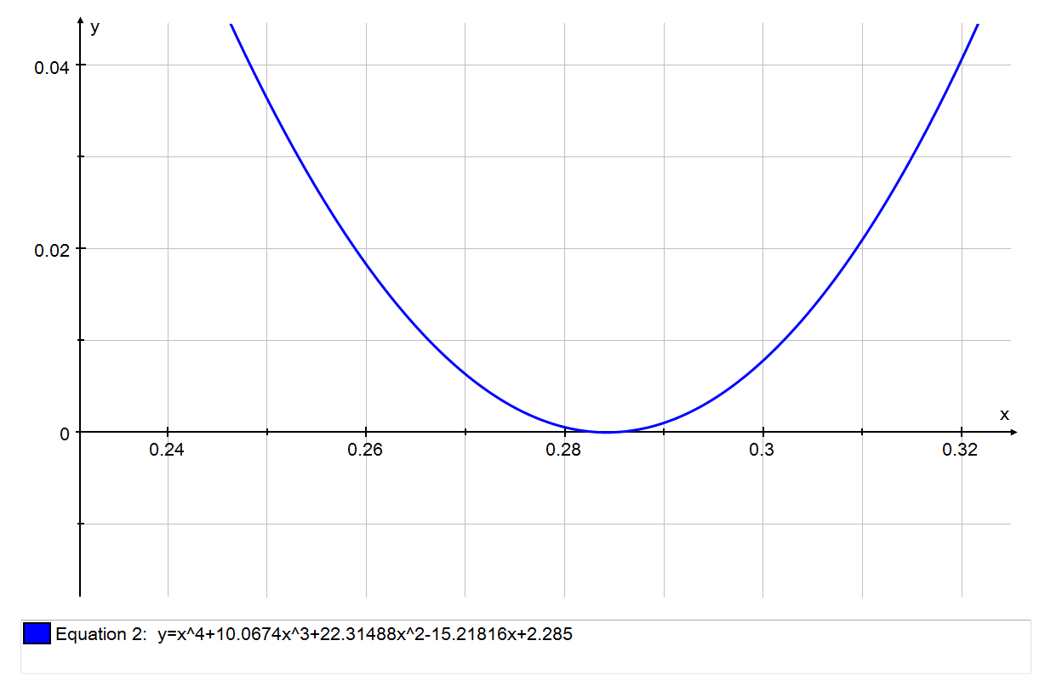

Figure 4: two roots between [0.27, 0.3] of the graph

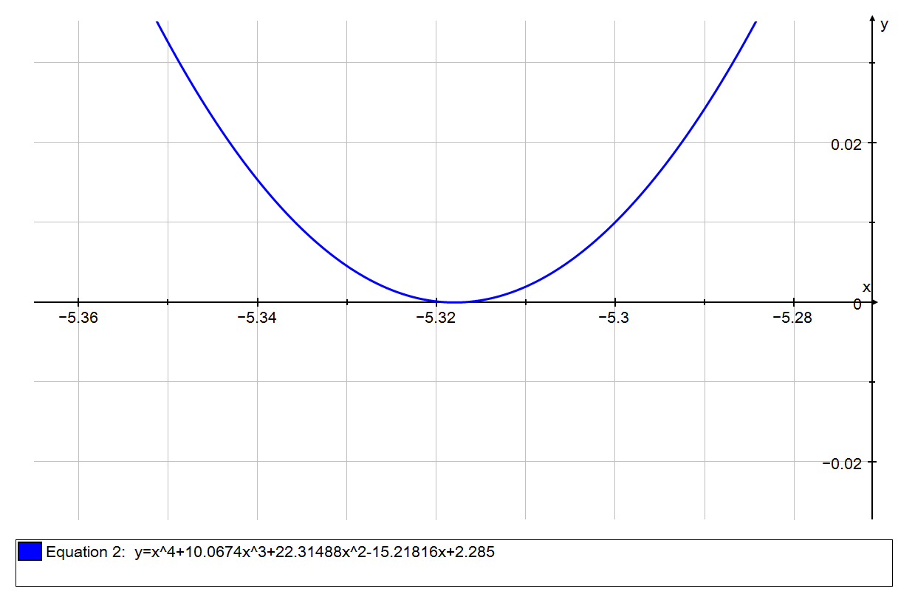

Figure 5: two roots between [-5.34,-5.3] of the graph

The table of values below show that between the points [0.2, 0.3] there is no sign change, however on closer inspection of the two roots it is seen that they cross the x-axis as seen in figure 6 below.

x f(x)

0.2 0.2161

0.21 0.1685

0.22 0.1266

0.23 0.09057

0.24 0.06047

0.25 0.03635

0.26 0.01828

0.27 0.006323

0.28 0.0005479

0.29 0.001022

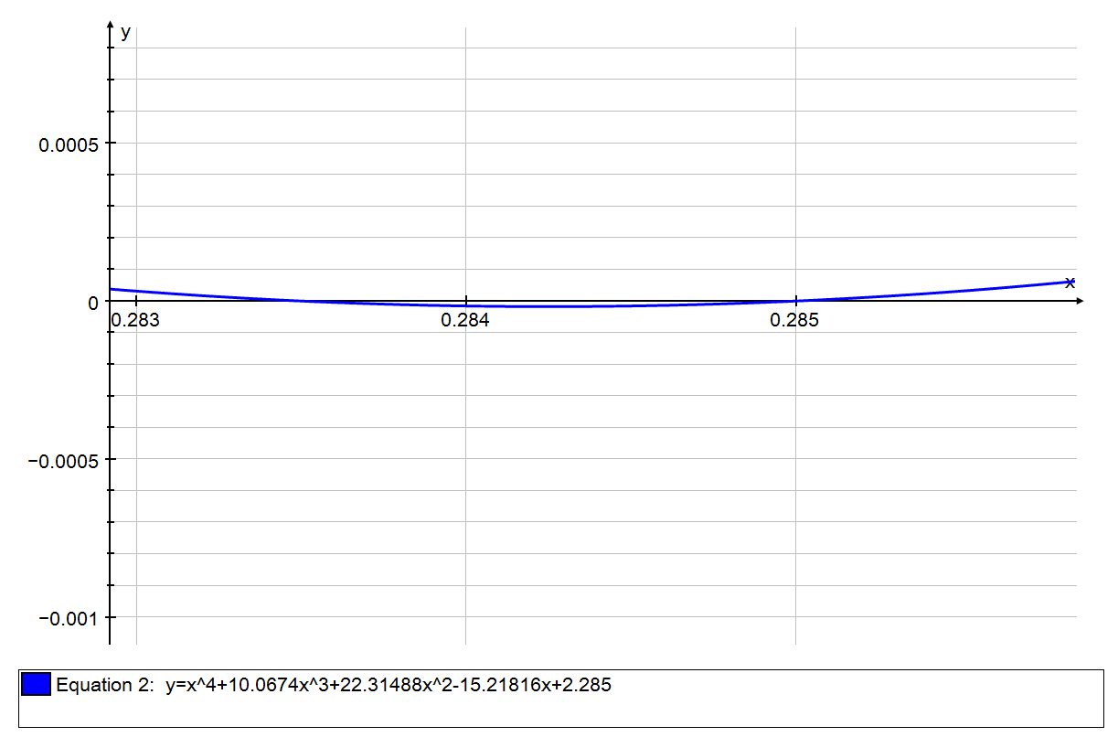

Figure 6: Showing the graph, , crosses the x-axis

This shows it as a failing case as it can’t find the two roots showing only that it lies above the x-axis.

Repeated root

Having a repeated root is a failing case as the graph won’t ever cross the x-axis, instead it only touches it. The graph below shows this failing case.

Figure 7: graph of with a repeated root, which only touches the x-axis.

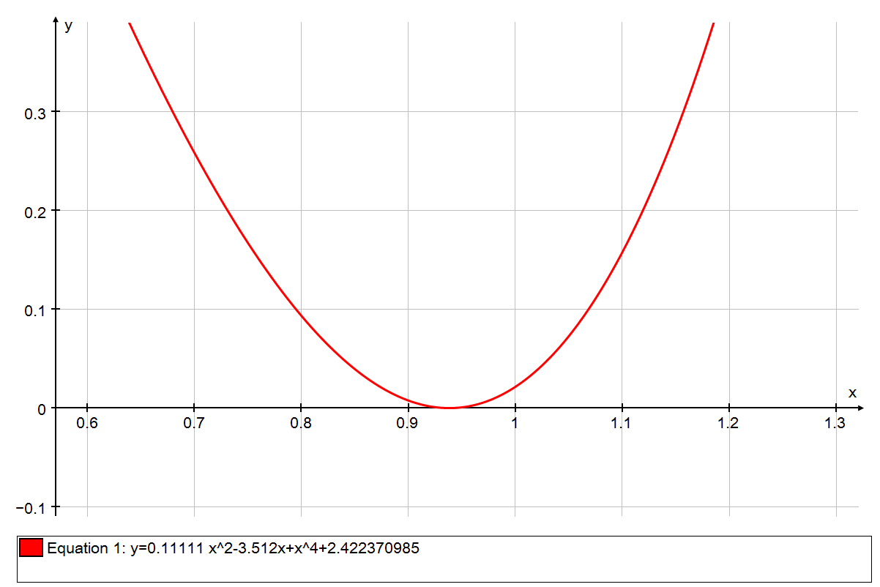

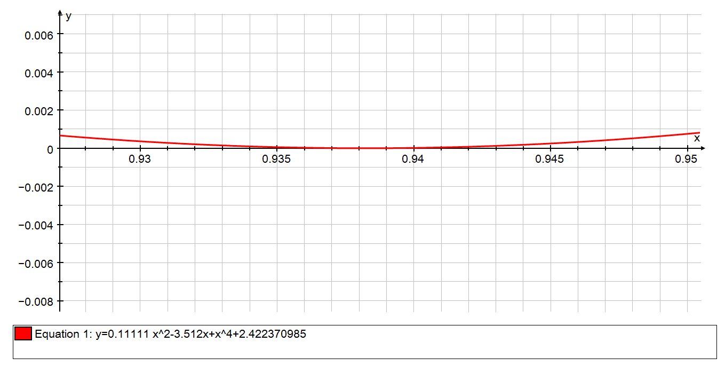The table of values below show that the graph does not cross the x-axis as there is no change in sign.

x f(x)

0.9 0.00767

0.91 0.004211

0.92 0.001767

0.93 0.000362

0.94 1.674E-005

0.95 0.000754

0.96 0.002597

0.97 0.005567

0.98 0.009689

0.99 0.01499

1 0.02148

False root

A false root occurs when the table of values cannot detect an asymptote and indicates that it is a root. I will show this using the graph:

Figure 8: graph of

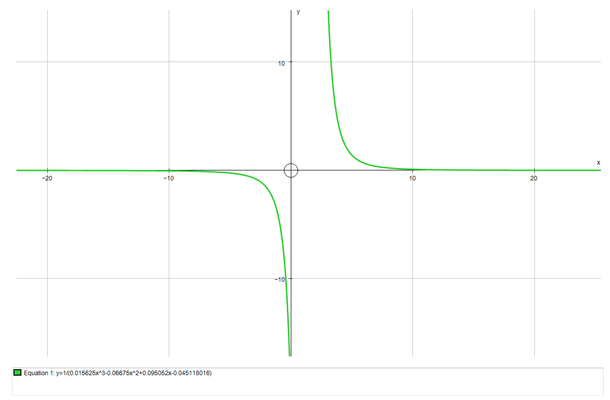

The table of values below show that there is a change of sign in the intervals [1, 2], usually this would mean that there is a root in the interval these points, however due to it being a reciprocal graph it is instead an asymptote and not in-fact a root, this is what we call a false root.

x f(x)

1 -839.6

1.1 -1882

1.2 -5694

1.3 -3.357E+004

1.5 1.458E+005

1.6 1.174E+004

1.7 3044

1.8 1204

1.9 593.4

Newton-Raphson Formula

The Newton-Raphson formula I used finds the solutions of an equation by finding estimates for one root using the tangent. After finding the estimate it then finds the function of that estimate and working out the root of that tangent, this is repeated using the formula to work out a closer estimate for the root each iteration. This carries on till the real root is found. How to derive the formula is shown below:

The gradient of a tangent is at the point is the differential of which is

The equation of a line can be written as:

So therefore the equation of the tangent is:

The tangent cuts the x-axis at the point , when it is put into the equation it becomes:

And then this equation re-arranged creates the newton Raphson formula shown below:

The graph that I am going to use is which is seen below:

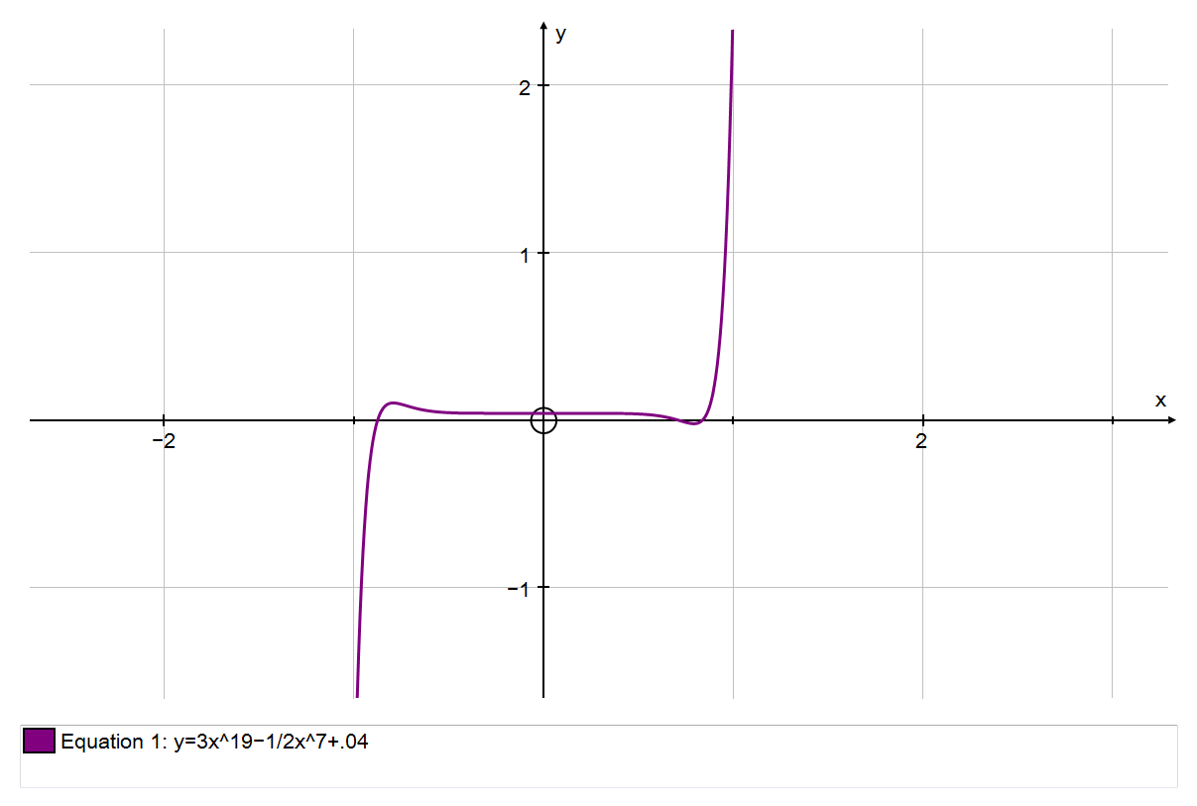

Figure 9: Graph of with 3 roots.

The differential of this equation is

Manual input of the formula

1st iteration

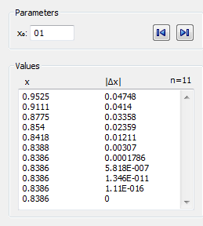

Figure 10: Newton-Raphson table for my first root

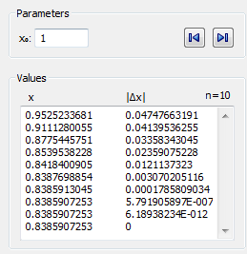

2nd iteration

These values and further iterations are shown above in a table and below on the graph:

Figure 11: Newton-Raphson iterations shown on a graph with the first value as . The formula is seen converging towards the root going from axis to curve.

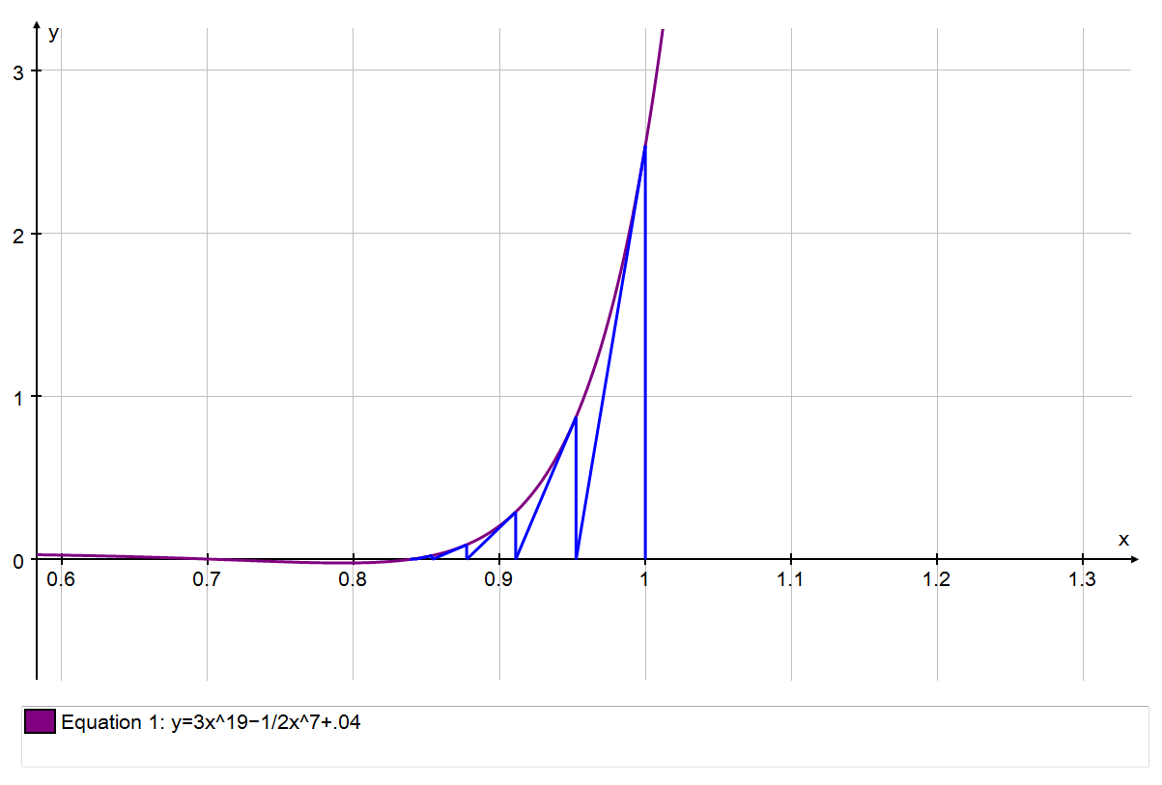

From the table we can see that the first root is .

Finding the other roots

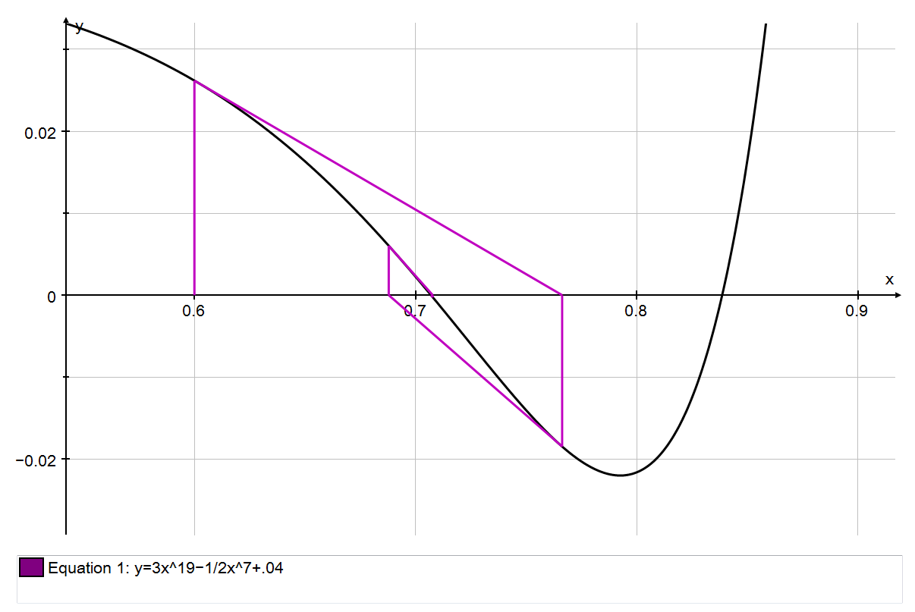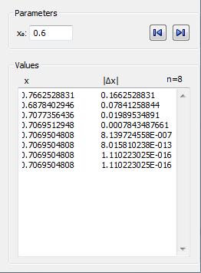

Figure 12: This shows my second root which is close to the point 0.7.

As seen above the Newton-Raphson method spirals around and converging onto the point. There is a limitation with the Auto-Graph software as the change in the x value repeats and does not go to 0, although it is close enough to 0 for us to say that we have found the root to a suitable degree of accuracy. Therefore the root is .

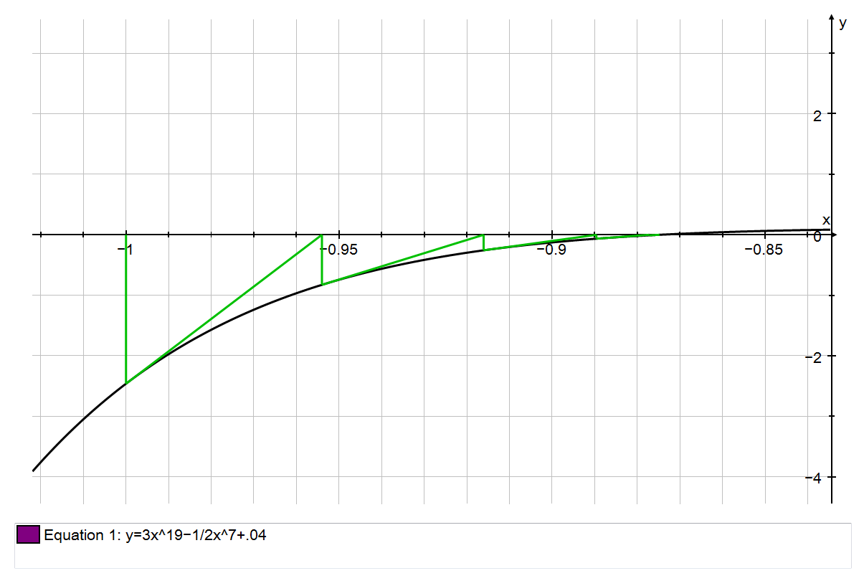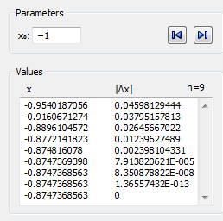

Figure 13: This shows the Formula being used on my final root close to x=-0.9

The Newton-Raphson formula converges on the root of the equation. Using the table above; we can see that the last root to my equation is .

Failing cases

The Newton-Raphson method fails to find a root to an equation when the root is close to an asymptote or if the table shows diverging values instead of converging. This would happen when the starting value is close to a turning point or asymptote.

Figure 14: Graph is a failing case of the Newton-Raphson method with the corresponding tables of values. Two sensible starting values that both do not work which means that you cannot solve this equation using this method.

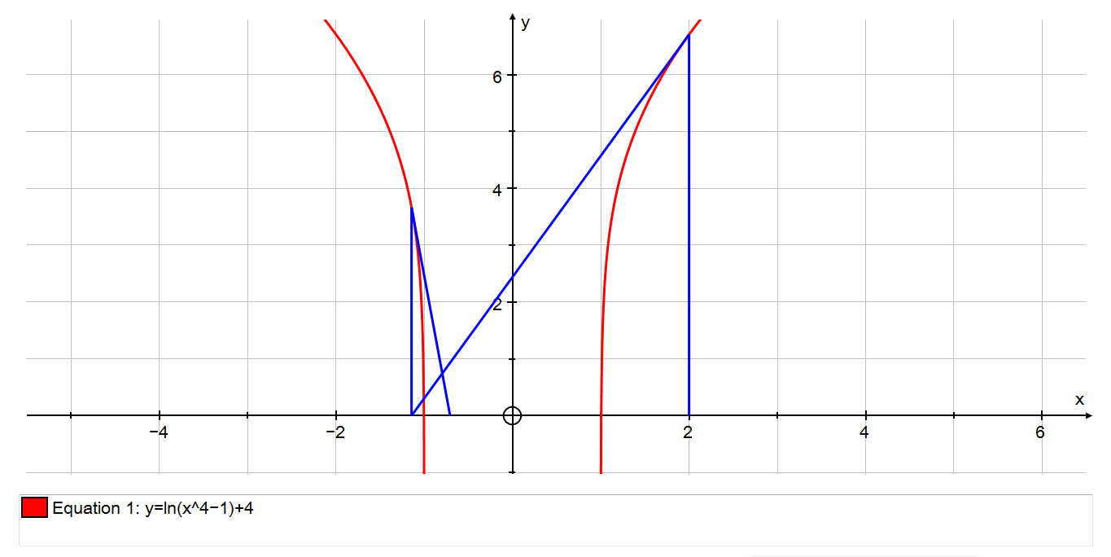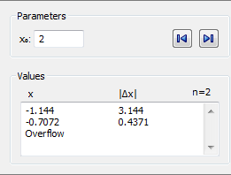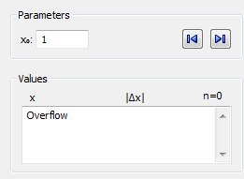

The table to the left states ‘overflow’ after the 1st iteration this means that it has failed by either the root being too close to the asymptote or the method has produced diverging iterations, to determine which case it is we just need to look at the graph which we can clearly see is diverging away from the root.

The reason why the graph in figure 14 has diverged is because at the point x=1 the gradient of the function is too flat or too steep leading the tangent away from the root. This means that the next iteration either does not have a value of; this could be so due to an asymptote preventing the graph from going further out.

Fixed-Point Iteration

Fixed-Point Iteration is when you rearrange your original equation to make the subject, which can be represented as. After the rearrangement you would do similar steps to that of the Newton-Raphson method by entering an integer close to the roots and then substituting in the answer into the equation, this achieves the same goal as the Newton-Raphson formula by finding more accurate estimations for the roots until the real root is found.

The equation I will be using the Fixed-Point Iteration with is:

The graph of this equation is given below:

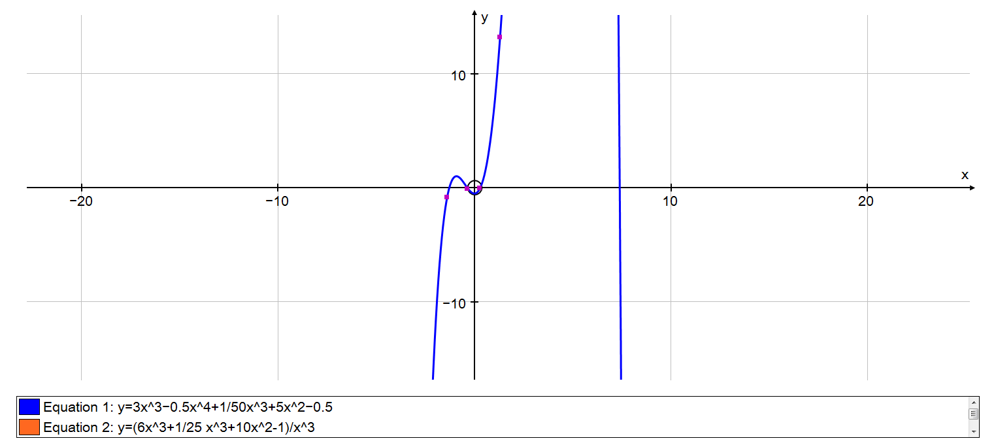

Figure 15: Graph of the equation , with roots in the intervals (-2, -1), (0,1) and (7,8)

Manual input of formula

I have rearranged my original equation to form a new one below:

This is only one of the ways that the equation can be re-arranged.

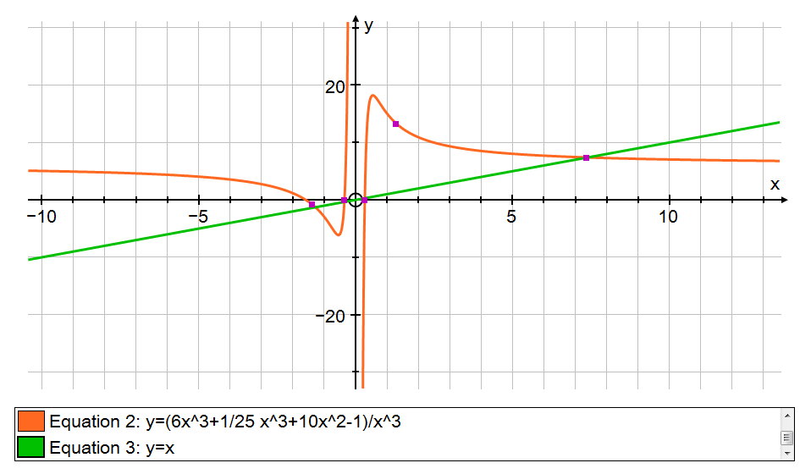

Figure 16: Re-arranged graph of the equation to with the line

To find the points of intersection we use the re-arranged formula in this form:

This will generate a closer estimate to the point of intersection by using the previously found estimate, this will be done until a desired level of accuracy is found for the estimate or the real value is found.

By differentiating the re-arranged equation and finding out that the gradient lies in the interval [-1, 1] we know that the graph converges to the root instead of diverging.

∴The method will converge to find the solution.

Let , Then:

Figure 17 above shows the full extent of the Fixed-Point Iteration formula giving the root as 7.390594008 to 10 significant figures.

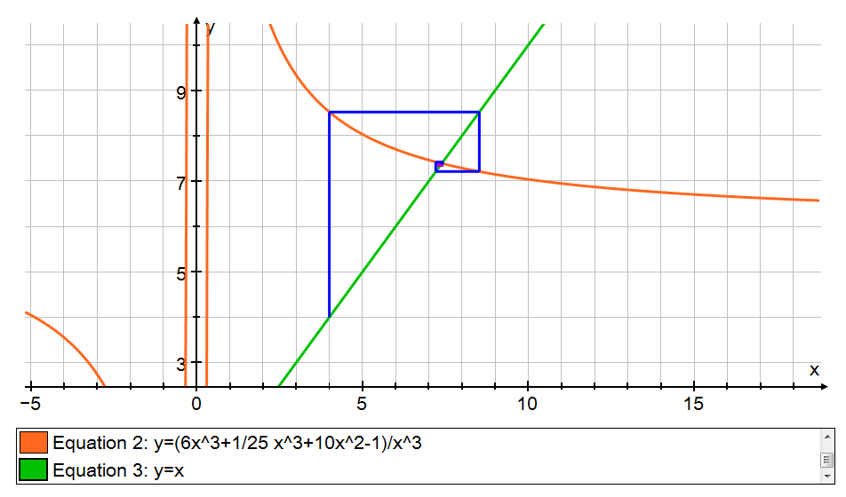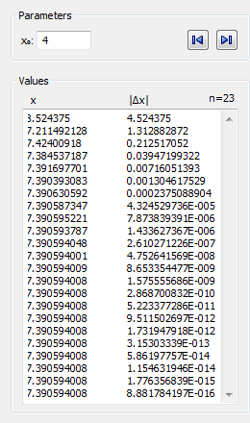

Figure 17: Fixed point iteration calculated by Auto-graph software

Failing case

Not all re-arrangements of the original equation work for example:

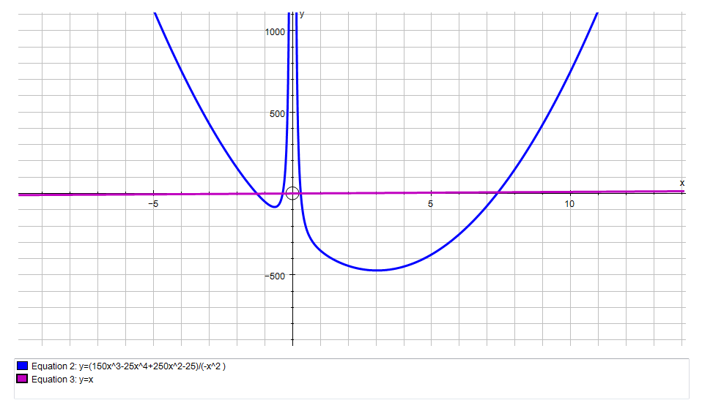

Figure 18: 2nd re-arrangement of the equation which is with the equation. Also showing the failing case of the fixed point iteration.

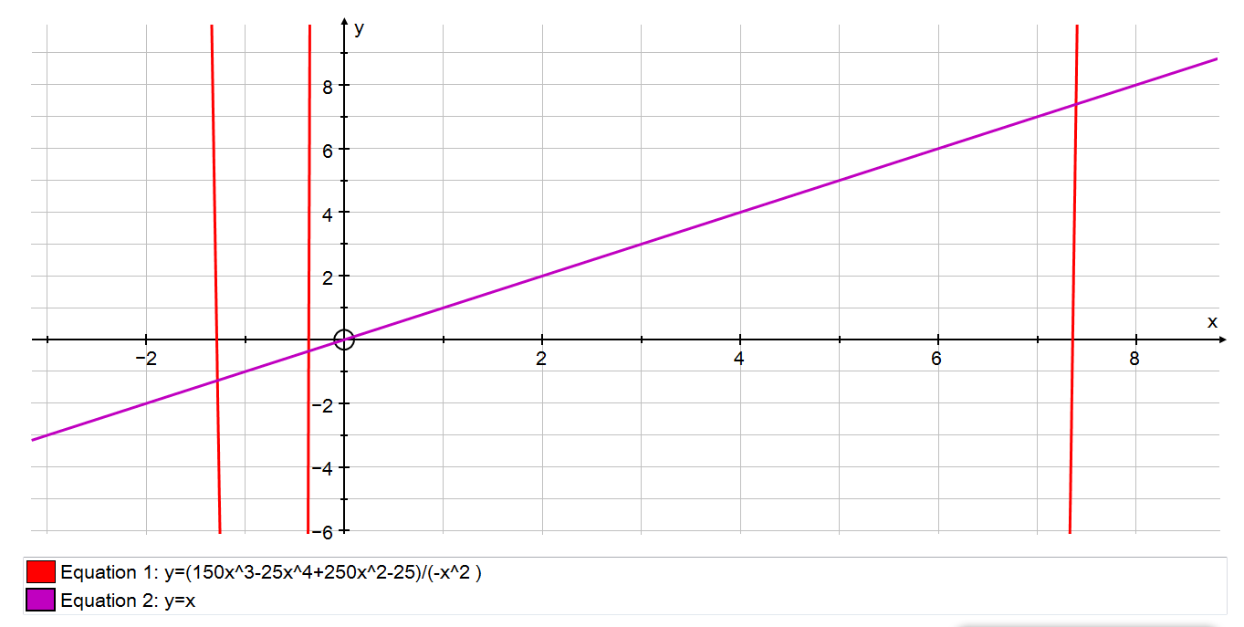

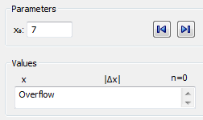

In figure 18 you can see that the Fixed-Point iteration calculations shows ‘Overflow’ this means that it was not able to calculate or estimate a value for the intersection. Another way to find out if it diverges instead of converging is to find the differential of the 2nd re-arrangement and if the gradient is greater or less than 1 or -1 respectively, the method will fail.

By differentiating the re-arranged equation and finding out if the gradient lies in the interval [-1, 1] we will find out if the graph converges or diverges.

using this starting value the method wont converge to the root due to thegradient being too steep .

Conclusion

To end I will need to be able to compare the 3 different methods. To do this I will be taking my working case for my Fixed-Point Iteration and applying both the decimal search and Newton-Raphson Methods. The equation that I will be using is:

And below is the graph of the equation above:

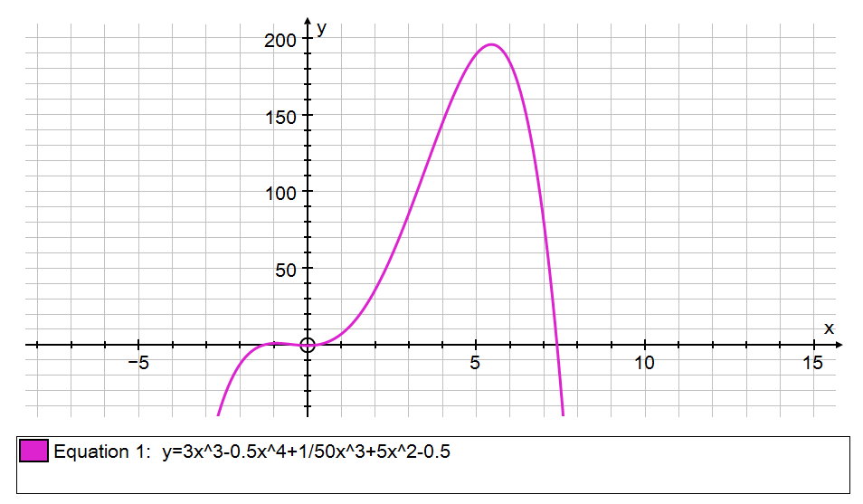

Figure 19: Graph of the equation with the root we wish to find between [7, 8]

From the fixed point iteration above I found that that the desired root is x = 7.390594008 to 10 significant figures. So now I will be using the other two methods and comparing the efficiency, accuracy and how time consuming they are.

Decimal Search

By looking at the graph we can see that the root lies in the interval [7, 8], using the table of values below we can see that there is a sign change between the x-values of 7.3 and 7.4 therefore we know that the root lies in the interval [7.3, 7.4]. This means that or .

x f(x)

7 79.86

7.1 61.86

7.2 42.22

7.3 20.87

7.4 -2.252

7.5 -27.22

7.6 -54.1

7.7 -82.97

7.8 -113.9

7.9 -147

8 -182.3

We know that this equation has a root in the interval [7.3, 7.4], using the table of values below we can see that there is a sign change between the x-values of 7.39 and 7.40 therefore we know that the root lies in the interval [7.39, 7.40]. This means that or .

x f(x)

7.3 20.87

7.31 18.64

7.32 16.39

7.33 14.12

7.34 11.84

7.35 9.535

7.36 7.214

7.37 4.875

7.38 2.517

7.39 0.1417

7.4 -2.252

We know that this equation has a root in the interval [7.39, 7.40], using the table of values below we can see that there is a sign change between the x-values of 7.390 and 7.391 therefore we know that the root lies in the interval [7.390, 7.391]. This means that or .

x f(x)

7.39 0.1417

7.391 -0.09688

7.392 -0.3356

7.393 -0.5746

7.394 -0.8137

7.395 -1.053

7.396 -1.293

7.397 -1.532

7.398 -1.772

7.399 -2.012

We know that this equation has a root in the interval [7.390, 7.391], using the table of values below we can see that there is a sign change between the x-values of 7.3905 and 7.3906 therefore we know that the root lies in the interval [7.3905, 7.3906]. This means that or .

x f(x)

7.39 0.141692175

7.3901 0.117843135

7.3902 0.09399225719

7.3903 0.07013954162

7.3904 0.04628498818

7.3905 0.02242859681

7.3906 -0.001429632584

7.3907 -0.02528970005

7.3908 -0.04915160568

7.3909 -0.07301534952

7.391 -0.09688093166

We know that this equation has a root in the interval [7.3905, 7.3906], using the table of values below we can see that there is a sign change between the x-values of 7.39059 and 7.39060 therefore we know that the root lies in the interval [7.39059, 7.39060]. This means that or .

x f(x)

7.3905 0.02242859681

7.39051 0.02004285658

7.39052 0.01765709797

7.39053 0.01527132098

7.39054 0.01288552561

7.39055 0.01049971187

7.39056 0.008113879738

7.39057 0.005728029228

7.39058 0.003342160339

7.39059 0.000956273068

7.3906 -0.001429632583

We know that this equation has a root in the interval [7.39059, 7.3960], using the table of values below we can see that there is a sign change between the x-values of 7.390594 and 7.390595 therefore we know that the root lies in the interval [7.390594, 7.390595]. This means that or .

x f(x)

7.39059 0.0009562730671

7.390591 0.0007176833291

7.390592 0.0004790934072

7.390593 0.0002405033014

7.390594 1.91301217E-006

7.390595 -0.0002366774613

7.390596 -0.0004752681182

7.390597 -0.0007138589593

7.390598 -0.0009524499838

7.390599 -0.001191041192

We know that this equation has a root in the interval [7.390594, 7.39595], using the table of values below we can see that there is a sign change between the x-values of 7.3905940 and 7.3905941 therefore we know that the root lies in the interval [7.3905940, 7.3905941]. This means that or .

7.390594 1.91301217E-006

7.3905941 -2.194602695E-005

7.3905942 -4.580506771E-005

7.3905943 -6.966411047E-005

7.3905944 -9.352315533E-005

7.3905945 -0.0001173822019

7.3905946 -0.0001412412499

7.3905947 -0.0001651003

7.3905948 -0.0001889593521

7.3905949 -0.0002128184059

We know that this equation has a root in the interval [7.3905940, 7.395941], using the table of values below we can see that there is a sign change between the x-values of 7.39059400 and 7.39059401 therefore we know that the root lies in the interval [7.39059400, 7.39059401]. This means that or .

x f(x)

7.390594 1.91301217E-006

7.39059401 -4.728913154E-007

7.39059402 -2.858795483E-006

7.39059403 -5.244699082E-006

7.39059404 -7.63060325E-006

7.39059405 -1.001650685E-005

7.39059406 -1.240241079E-005

7.39059407 -1.478831467E-005

7.39059408 -1.717421856E-005

7.39059409 -1.956012295E-005

7.3905941 -2.194602678E-005

We know that this equation has a root in the interval [7.39059400, 7.3959401], using the table of values below we can see that there is a sign change between the x-values of 7.390594008 and 7.390594009 therefore we know that the root lies in the interval [7.390594008, 7.390594009]. This means that or .

x f(x)

7.390594 1.91301217E-006

7.390594001 1.674421924E-006

7.390594002 1.435831564E-006

7.390594003 1.197241147E-006

7.390594004 9.586507304E-007

7.390594005 7.200603136E-007

7.390594006 4.814698968E-007

7.390594007 2.428795369E-007

7.390594008 4.289063327E-009

7.390594009 -2.34301524E-007

Due to the limitations of the autograph software only able to go to 10 significant figures we can only find the root to that degree of accuracy. So from the table below we can see that the root is 7.390594008 to 10sf which is the same as the value we found in the fixed point iteration.

x f(x)

7.390594008 4.289233857E-009

Therefore 10sf

7.390594008 -1.956965434E-008

7.390594008 -4.342871307E-008

7.390594008 -6.728782864E-008

7.390594008 -9.114694421E-008

7.390594008 -1.150058324E-007

7.390594009 -1.38864948E-007

7.390594009 -1.627240067E-007

7.390594009 -1.865831791E-007

7.390594009 -2.104420105E-007

7.390594009 -2.343011261E-007

To find one of the roots to the equation it took us 10 iterations which I had to write the values in manually every time.

Newton-Raphson

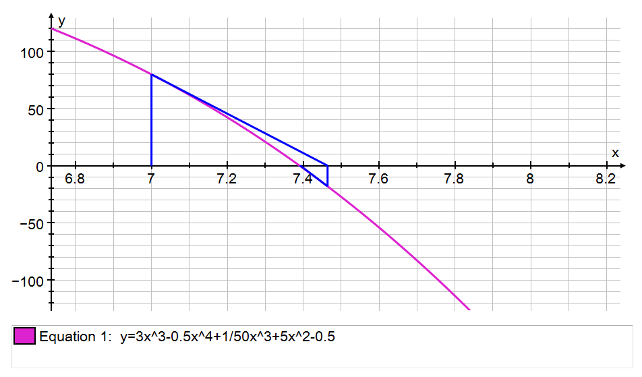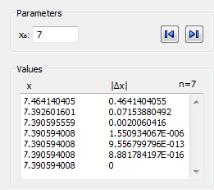

Figure 20: Newton-Raphson iterations for the f(x) graph .

In figure 20 we can see that the root of the equation is given as x = 7.39054008 and it has done this in 7 iterations.

In the previous pages you can see that I used all three formulas to find a root of one single equation. All three found the root correct to 10 significant figures however all 3 of them took different lengths of time as well as a different amount of iterations. From carrying out the calculations I felt that the decimal search method took the longest time, this is due to you having to find the next iterations by hand, although it only took 10 iterations to find the root it still took too long as I had to do a great deal more calculations than the other methods. I found that the Newton-Raphson method took the quickest by far, it took only 7 iterations, it took such a short time due to the software however when done by hand it takes longer than the fixed point iteration does by hand. The Fixed-Point Iteration took a while to perform but this was only due to having to find a re-arrangement that works, this was a problem as it caused me to have to change my original multiple times. I would say that this method was the most accurate as it took 23 iterations to reach the desired root as well as being the fastest method to be done by computer and by hand. Overall I think that the best one is still the Newton-Raphson method due to its simplicity and how easy it was to use both by computer and by hand. When doing this I had to consider the human error of using the software’s as well as calculations done by hand, and there are a few errors that are possible like poor choice of starting values and poor rearrangement of as well as incorrect input of values. There are failing cases in all of the methods however the iteration method is most likely to have failing case due to having many rearrangements which result in a too steep of a gradient which causes the method to fail.